Trevor McLaurine

5/29/2023

Assignment 2.3

**Steps to connect interpreter**

1. Open up visual studio codes and open the extensions tab.

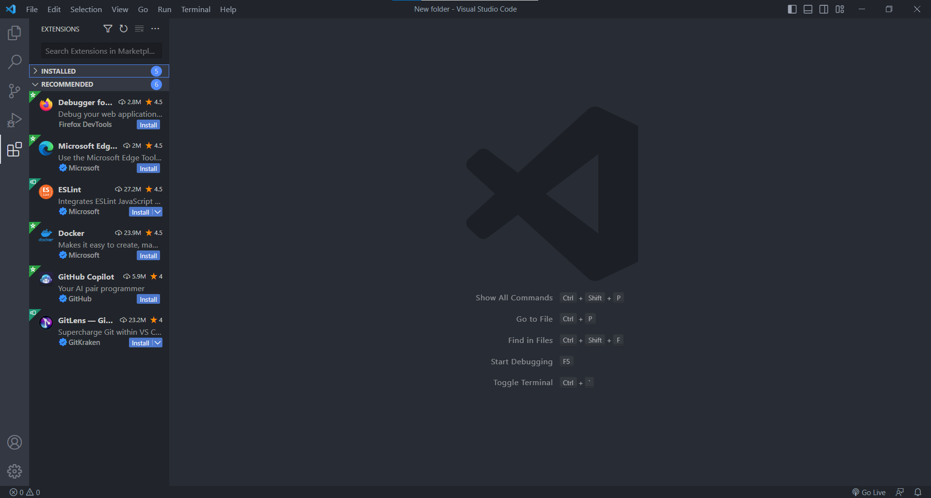

2. Search for Python in the extensions tab

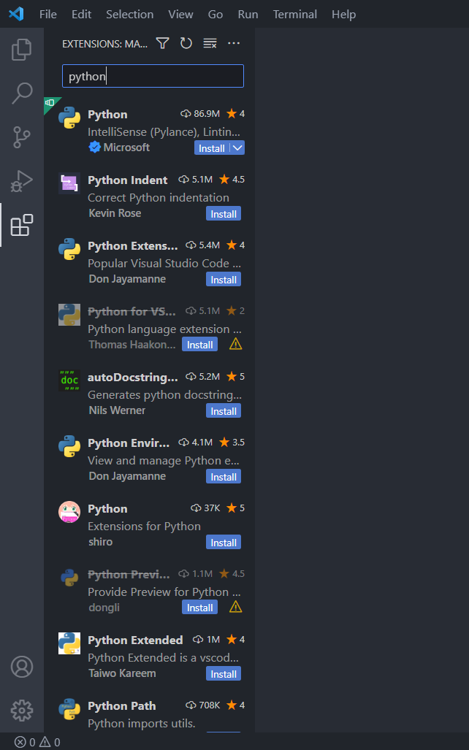

3. Select ‘Python’ and download.

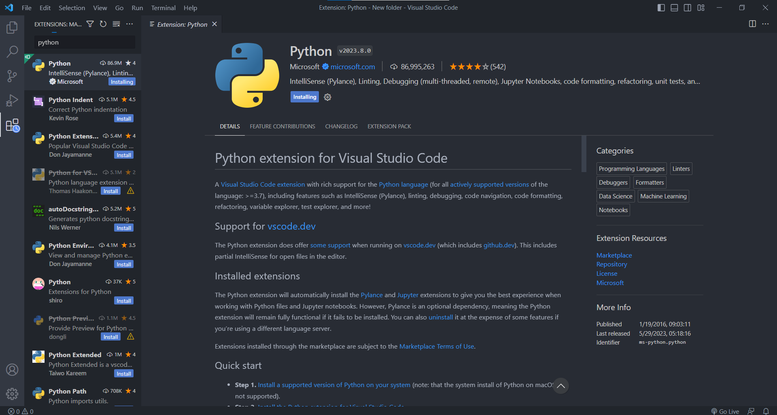

4. Once installed, on VScode, press Cntrl + shift + p. Search for ‘Selected Interpreter: Python’ and select the recommended option.

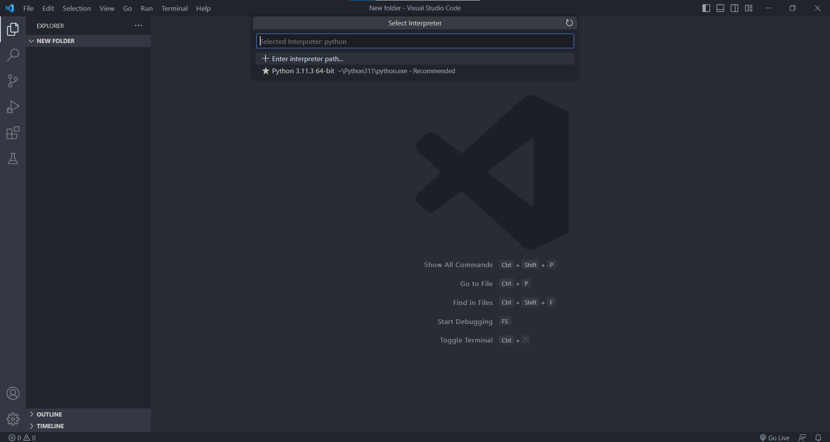

**Code and Results**

